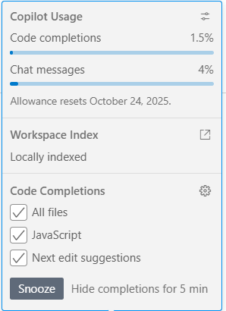

**Copilot Usage**

Code completions1.5%

Chat messages4%

Allowance resets October 24, 2025.

**Workspace Index**

Locally indexed

**Code Completions**

All files

JavaScript

Next edit suggestions

Hide completions for 5 min